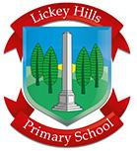
Starting School and New Admissions
We wish all of our prospective new families a very warm welcome to Lickey Hills Primary School and Nursery and look forward to meeting with you very soon.
Coming soon you will receive communication about our transition programme and key dates. You will also receive online paperwork to complete please. In the meantime, if you have any questions or queries, please do get in touch with our wonderful office team who will either be able to help you or will signpost you to the relevant person.
In the meantime, please have a look at some useful links to support you and your child in being school ready.
Kind regards
Mrs Reading- EYFS lead

Please note that we do not allocate our own admissions into Reception. This is done by Worcestershire City Council. If you have not been offered your choice of school please get in touch with County admissions.

