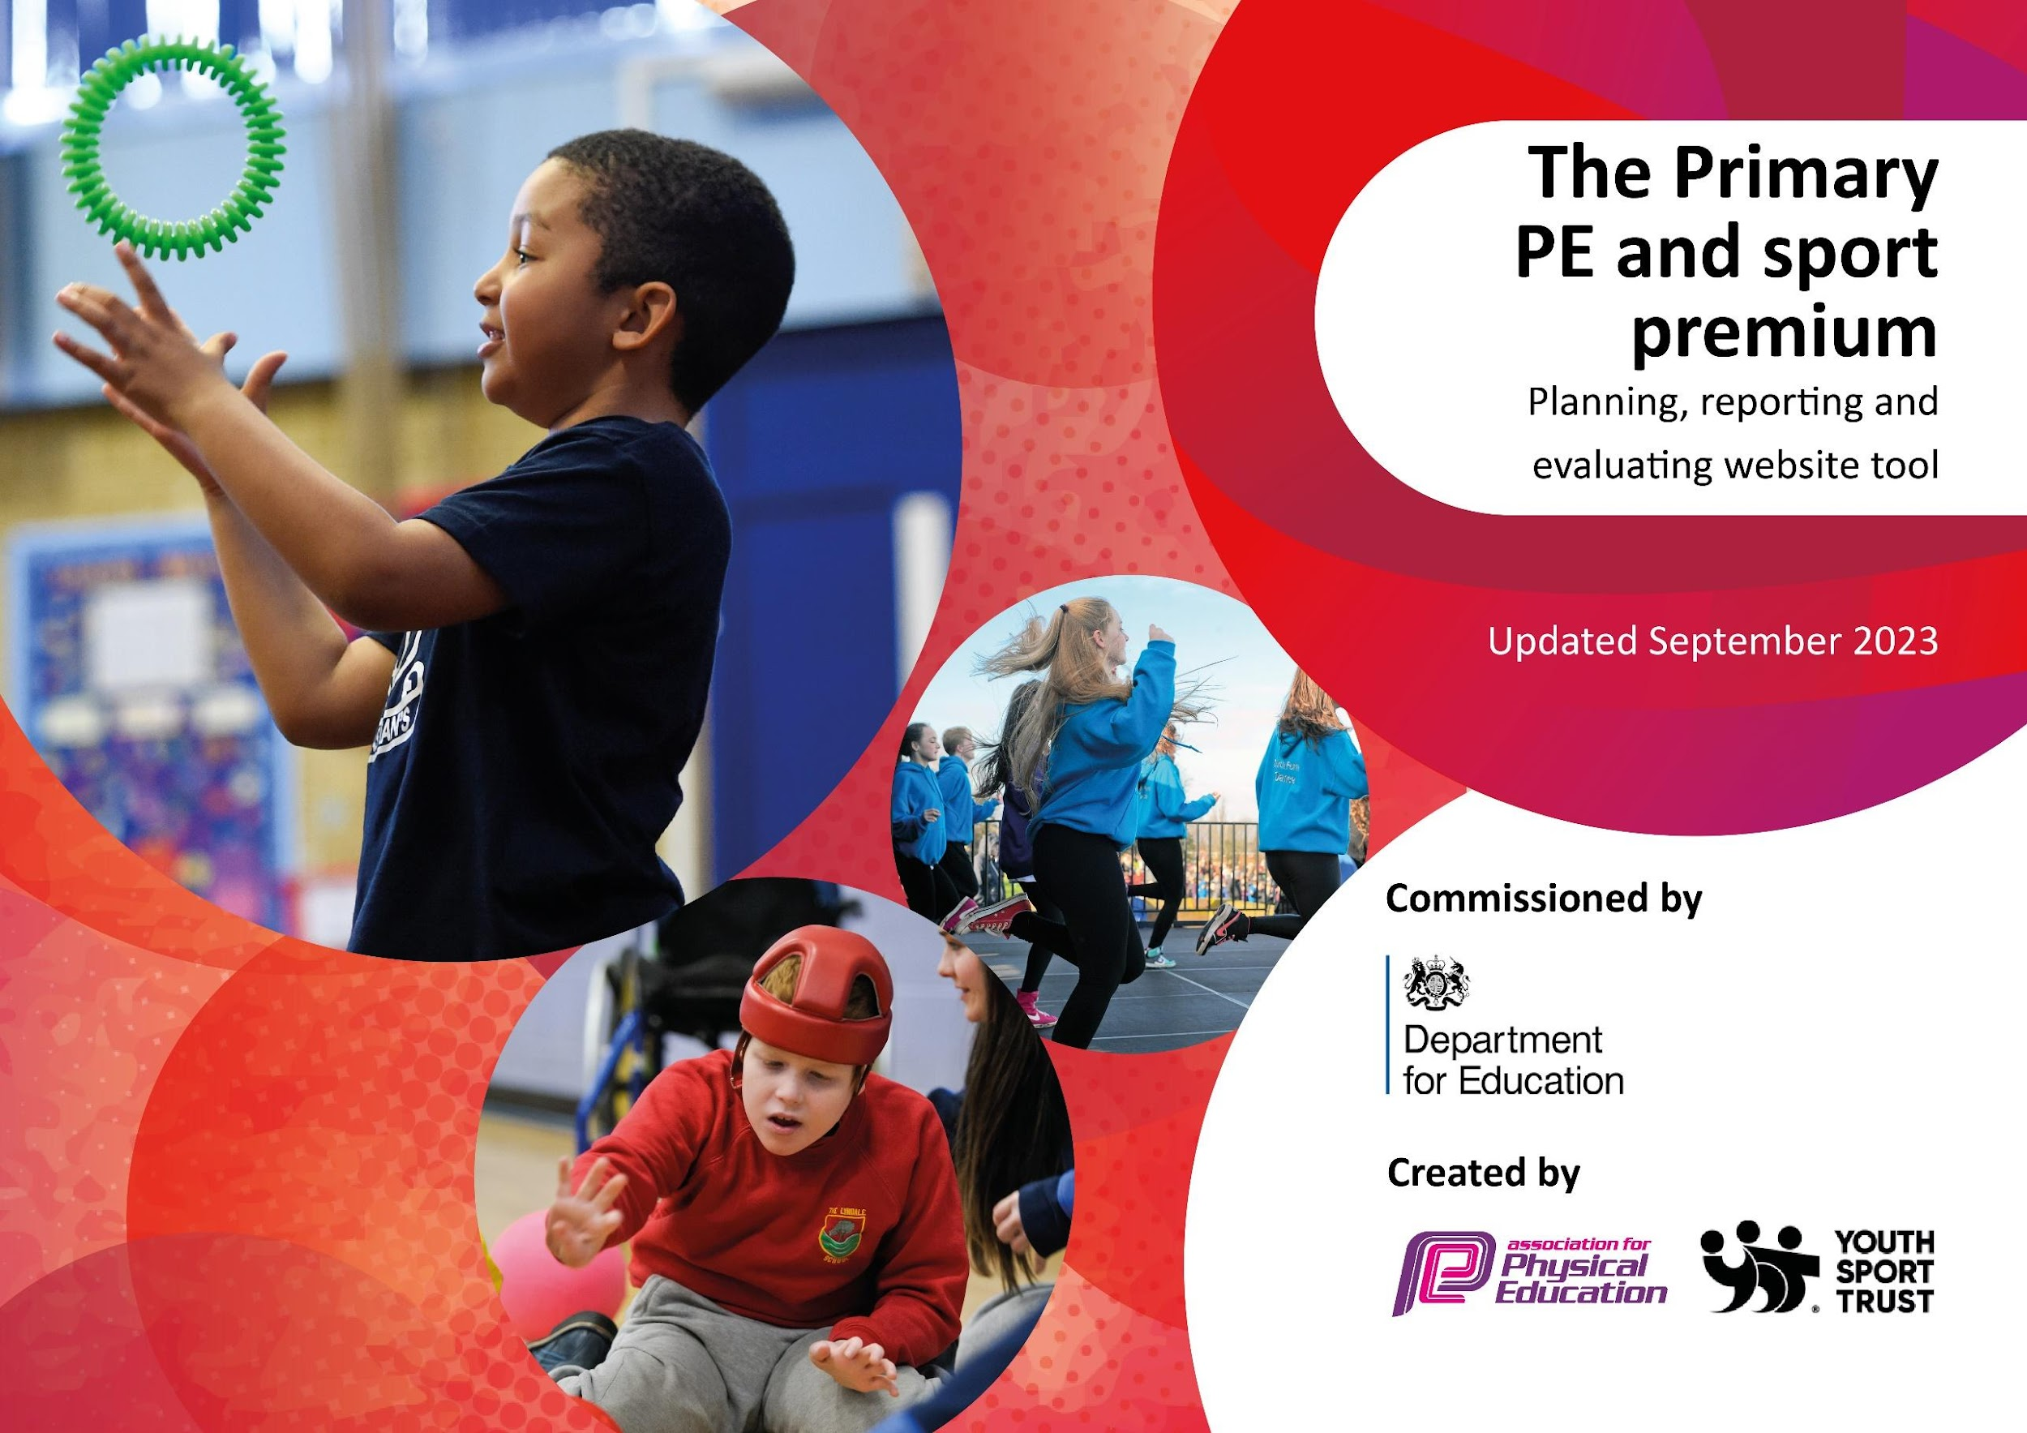

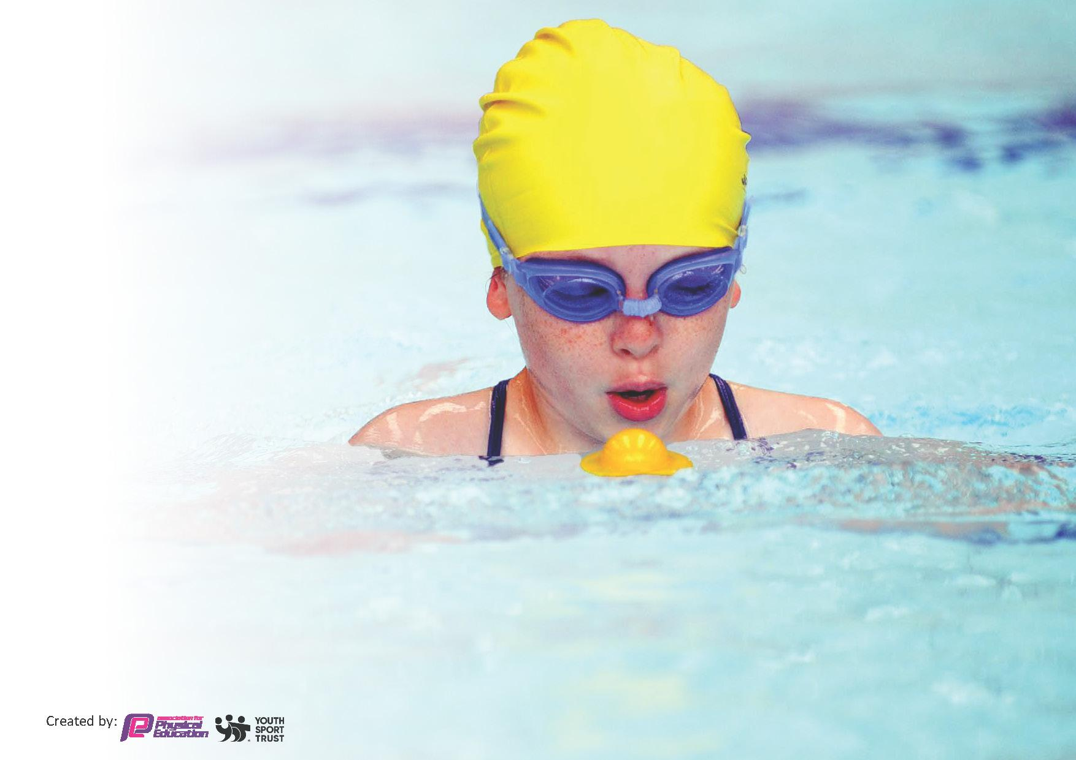
This template can be used for multiple purposes:
by:
- It enables schools to effectively plan their use of the Primary PE and sport premium
- It helps schools to meet the requirements (as set out in guidance) to publish information on their Primary PE and sport premium
- It will be an effective document to support Ofsted inspections enabling schools to evidence progress in Physical Education (PE) and evidence swimming attainment, which forms part of the PE National Curriculum. We would recommend schools consider
the Intent, Implementation and Impact of any spend, as examined within the Education Inspection Framework.

It is important that your grant is used effectively and based on school need.

Schools must use the funding to make additional and sustainable
improvements to the quality of the PE, School Sport and Physical Activity (PESSPA)
they offer. This means that you should use the Primary PE and sport premium to:

- Build capacity and capability within the school to ensure that improvements made now will benefit pupils joining the school in future years
- Develop or add to the PESSPA activities that your school already offers.

The Primary PE and sport premium should not be used to fund capital spend projects; the school’s core budget should fund these. Further detail on capital expenditure can be found in the updated Primary PE and sport premium guidance.

The Primary PE and sport premium guidance, outlines 5 key priorities that funding should be used towards. It is not necessary that spending has to meet all the key priorities, you should select the priorities that you aim to use any funding towards.

Although completing this template is not a requirement for schools, schools are required to publish details of how they spend this funding. Schools must also outline what the impact this funding has had on pupils’ PE and sport participation and attainment and how any spending will be sustainable in the future. All funding must be spent by 31st July 2024.

The Department for Education has worked closely with the Association for Physical Education (afPE) and the Youth Sport Trust (YST) to develop this template and encourages schools to use it. This template is an effective way of meeting the reporting requirements of the Primary PE and sport premium.

Review of last year’s spend and key achievements (2022/2023)

We recommend you start by reflecting on the impact of current provision and reviewing your previous spend.
£19,410

Activity/Action | Impact | Comments
Re-establishing the Daily Mile into the school timetable and extending it to KS1.  Investing in new equipment to deliver the new curriculum effectively and give the children maximum opportunity to participate in lessons.  To source and use an effective and clear scheme of work for staff to deliver their PE and Games lessons.  To offer CPD opportunities through AAA to staff who would like it.  Forest Schools  Playground equipment purchased to led to more active lunchtimes for the children  Through Get Set 4 PE, our new PE curriculum includes a wider variety of different sports, e.g. Volleyball, yoga, dodgeball. | Through Pupil Voice, children will be able to explain the importance of exercise and regular exercise.  Appropriate equipment will be purchased to match the new PE curriculum. Every child will be able to participate in all lessons.  Through talking to staff, Pupil Voice and teacher assessment, we will see an increase in enthusiasm in delivering and participating in PE.  This has been moved to academic year 23/24 with the first training taking place in September.  Forest school sessions will be equipped to give the children wide and varied opportunities to learn new skills.  Children will have a variety of equipment to use during lunchtimes which will help keep the children active and reduce boredom which can lead to behaviour issues.  Increased use of the AAA and cluster school events will give children greater opportunities to learn and compete in a greater range of sports and will inspire the less keen children to participate in sporting activities. | This is now fully embedded in KS2. In KS1 the children carry out daily mile at the start of their afternoon playtime.  Equipment purchased and a new PE cupboard has been built to accommodate and keep centrally.  Fully embedded across school, positive feedback from staff and children.  Next step will be monitoring of the quality of PE lessons by the PE lead.  A timetable of training is held by the PE lead and shared with staff regularly. PE lead to hold a twilight training session 23/24  22/23 - Yr6 took part in Forest School sessions each week. 23/24 will be Yr1. Forest school is now resourced.  A range of lunchtime equipment has been purchased however there is a need for more across the three key stage playgrounds.  The sports offer to the children in each key stage has been enhanced with sports events such as multi skills events, sports aimed at PP and children reluctant to engage in sports, speed stacking, yoga as well as training for our play leaders.

Key priorities and Planning
This planning template will allow schools to accurately plan their spending.

Action – what are you planning to do | Who does this action impact? | Key indicator to meet | Impacts and how sustainability will be achieved? | Cost linked to the action
Equip new MUGA facility | All children able to use MUGA for full range of sporting opportunities and access to wider PE curriculum. | 4. Offer a broader and more equal experience of a range of sports and physical activities to all pupils | Children participating in high quality sports education and extra-curricular activities accessing high quality facilities. | Approximately £7,000 costs.
Ensure appropriate staffing in place to ensure children are able to attend all cluster fixtures. | All children able to access competition in full range of sports | 5: Increased participation in competitive sport. | Children experiencing competitive sporting activities and being exposed to new sporting activities | Approximately  £2000 coach costs  Approximately  £2000 staffing cover costs
Train playleaders  Train wellbeing champions | A group of Year Six children will be trained through the AAA to support lunchtime play in EYFS/KS1 and a group will be training to support children's wellbeing. | 3. Raising the profile of PE and sports across the school to support whole school improvement | Children in EYFS and KS1 will be engaged in fun physical games and activities. Children will have access to wellbeing leads to help with their SEMH. | Included in approximately £3000 cost of AAA SLA
Continue to enhance the school sporting offer through the purchase of further equipment | Through staff and pupil voice further equipment will be chosen and purchased to enhance our playtime/lunchtime activity offer | 2. The engagement of all pupils in regular physical activity – the Chief Medical Officer guidelines recommend that all children and young people aged 5 to 18 engage in at least 60 minutes of physical activity per day, of which 30 minutes should be in school. | Children will have a variety of equipment to use during lunchtimes which will help keep the children active and reduce boredom which can lead to behaviour issues. | Approximately  £1000
To offer CPD opportunities through AAA to staff who would like it. | Staff shared into potential training opportunities through AAA and covered to attend | 1. Increased confidence, knowledge, and skills of all staff in teaching PE and sport. | The children will have access to higher quality PE lessons as well new and varied extra curricular activities | Approximately  Included in £3000 cost of AAA SLA
To update and enhance playground markings to ensure full-breadth of extra-curricular and curriculum offer. | Full range of playground markings to supports a greater breadth of offer for all children. | 2. The engagement of all pupils in regular physical activity | The children will have access to specific sporting areas not just for outdoor PE lessons but to enhance playtimes/lunchtimes and extra curricular sporting clubs | Approximate cost of £2000

Key achievements 2023-2024
This template will be completed at the end of the academic year and will showcase the key achievements schools have made with their Primary PE and sport premium spending.

Activity/Action | Impact | Comments

Swimming Data
Meeting National Curriculum requirements for swimming and water safety.
Priority should always be given to ensuring that pupils can perform safe self-rescue even if they do not fully meet the first two requirements of the National Curriculum programme of study

Question | Stats: | Further context  Relative to local challenges
What percentage of your current Year 6 cohort can swim competently, confidently and proficiently over a distance of at least 25 metres? | % | Use this text box to give further context behind the percentage.  e.g., 30% - we are struggling to get pool space due to our local pool closing so we have had to use a much smaller local school pool. We have had to limit the number of pupils attending swimming lessons during one term which means some pupils have attended fewer swimming lessons than others.
What percentage of your current Year 6 cohort can use a range of strokes effectively [for example, front crawl, backstroke, and breaststroke]? | % | Use this text box to give further context behind the percentage.  e.g., Even though your pupils may swim in another year please report on their attainment on leaving primary school at the end of the summer term 2024

What percentage of your current Year 6 cohort are able to perform safe self-rescue in different water-based situations? | % | Use this text box to give further context behind the percentage.
If your schools swimming data is below national expectation, you can choose to use the Primary PE and sport premium to provide additional top-up sessions for those pupils that did not meet National Curriculum  requirements after the completion of core lessons. Have you done this? | Yes/No
Have you provided CPD to improve the knowledge and confidence of staff to be able to teach swimming and water safety? | Yes/No

Signed off by:

Head Teacher: | D. Dathan
Subject Leader or the individual responsible for the Primary PE and sport premium: | D. Dathan and L. Matthews
Governor: | M Claydon
Date: | 13.11.23

