Activities for children in Reception for School Closure
Due to the closure of schools we have composed the following so that you will be able to continue to support your child at home with their learning. The following is a range of suggested activities but please make sure each day you spend time reading, practicing sounds , writing simple sentences and recognising, counting and ordering numbers. Counting and ordering numbers to 10, 15 and aiming to be secure within 20 as appropriate. If they are confident with this, feel free to extend your child’s learning to include larger numbers.
Personal, social, emotional activities
The following activities will help children to meet these objectives eg welcoming praise, being willing to complete a job, taking turns, recognising the needs of others, recognising things they are good at etc.
Playing with your child will help to further support the development of your child, whether it is developing interaction with an adult and/or siblings.
Play games that encourage children to take turns e.g. board games. For some children it will help them recognise that they can not always be first, to help them to deal with losing a game and how they manage their feelings in that situation.
Encourage children to make their own choices when selecting what to play and to recognise things they are good at or equally things they need help with.
When they have finished playing, encourage your child to take responsibility for putting their toys away. You can also encourage them to complete little jobs as they develop a sense of helping others and recognise the needs of others.
When playing, or through stories you share, use arising opportunities to model and talk about different feelings and emotions.
Communication and Language activities
The following activities will help support the development of objectives such as following instructions, allowing others to take a turn when talking, to talk about ideas and experiences with growing command of tense and increasing vocabulary, to be able to develop increasing concentration with the aim that they can stay focused on a task and be able to listen and do at the same time.
We encourage the children to follow 4 listening rules: look at the person who is talking, listen to all of the words, sit still and stay quiet when the person is talking.
You can play games to help develop listening skills eg:
- I spy
- Have a hunt where children have to listen to clues to find something
- Play the ‘hot, cold’ game- you have to hide something and if the child is nearby the item you say ‘warm’ or ‘hot’ as appropriate. Equally if the child is far away you would say ‘cold’ or ‘freezing’ as appropriate.
- Take turns to give each other instructions to fetch or do something eg simon says touch your toes, tap your head. How many instructions can your child follow?
- Play a game eg snap or snakes and ladders.
Physical development
The following activities will help to develop effective muscle development and to encourage children to use and control tools effectively and with purpose.
Fine motor skills
Developing muscles and hand eye coordination activities include threading, building using various manipulatives such as duplo or lego, keyboard skills etc.
Playdough is a great all-rounder to develop a range of muscles. If you don’t have any there are many playdough recipes online.
Cutting skills practice cutting ensuring your children can hold the scissors correctly and safely using one hand. Your child should be able to cut with control and purpose.
Can they snip?
Can they cut a line?
Can they cut different styles of lines eg a circle or wavy lines?
Can they cut out a picture with accuracy?
For extra challenge change the thickness of paper or material. Use different scissors with different blades eg zig zag blades.
Letter formation
On our Reception website are the letter shape groups that we follow when teaching children letter formation. Please use this time to spend practicing letter formation. Lots of repetition will really help embed the correct formation of a letter. Please refer to the letter formation you have all been given to help teach your child how to form the letter correctly. You can start using large paper and write big letters if that is easier and you can make letters in different ways eg in sand, in a cornflour and water gloop, placing objects on the letters etc.

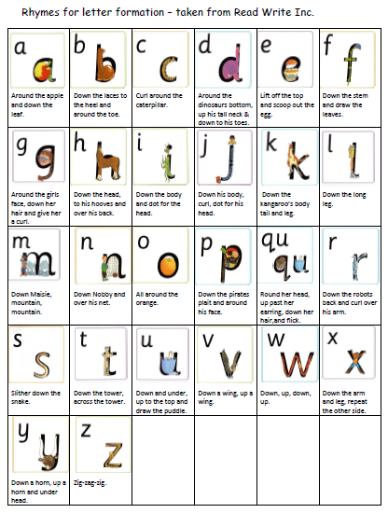
The aim is for children to form letters that are consistent in size but also with regard to taller letters (ascenders) and letters that go below a line (descenders) being identifiable. Encourage children to write on lines to support this.

Pencil hold- Tripod position
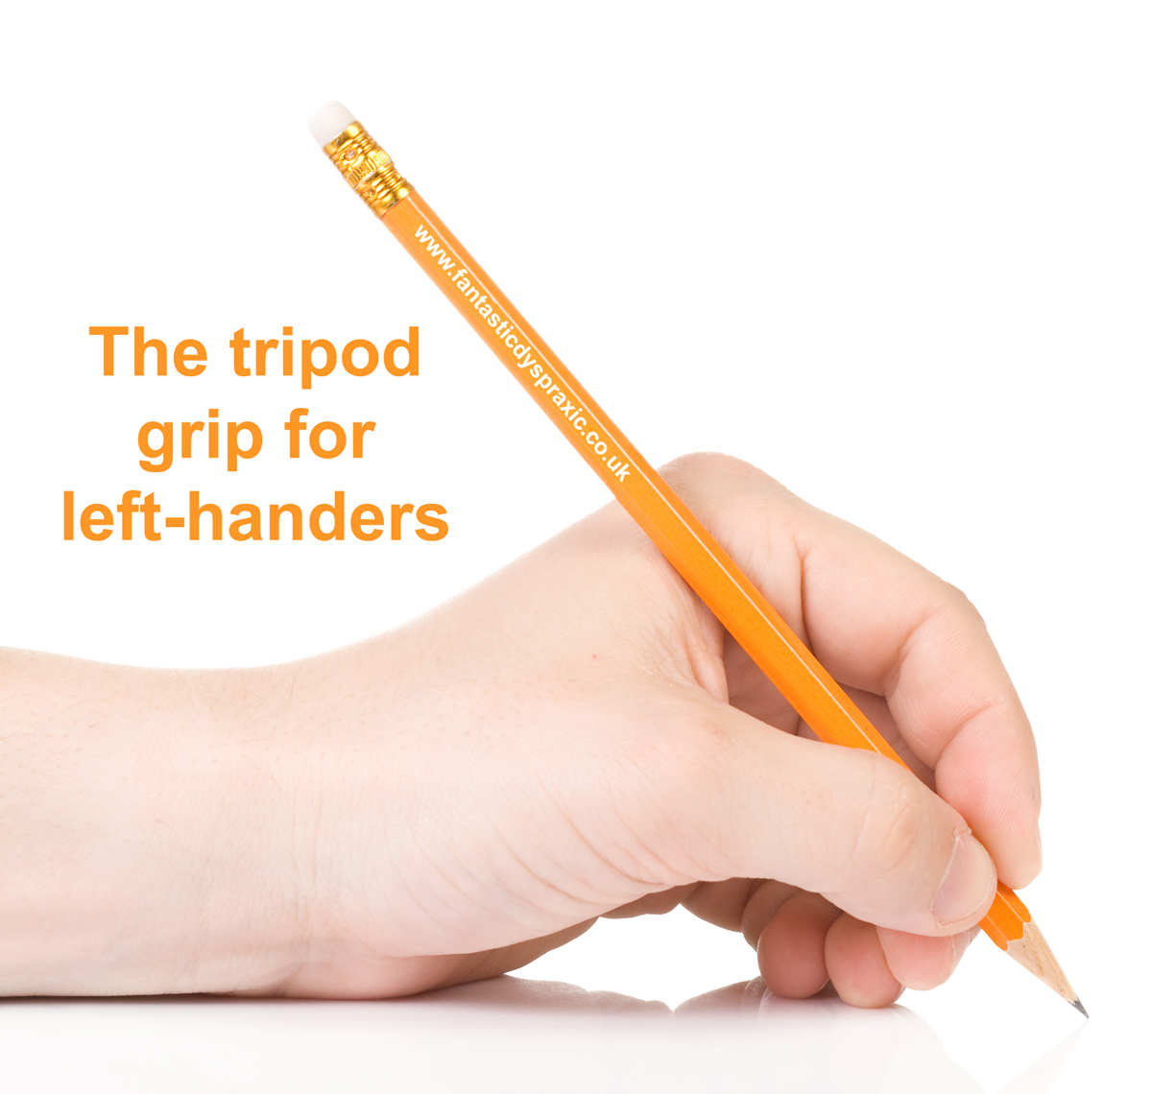

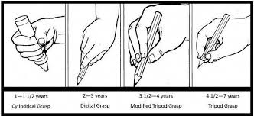

Outside activities
If you can go outside, encourage children to develop spatial awareness moving in different ways and speeds. Teach or support your child to throw and catch balls, bounce, kick, throw balls into targets. You can add challenge by varying the object used or the height or distance. You can play games such as ‘piggy in the middle.’
Other ways to be active:
Yoga- there are lots of cosmic kids videos on youtube available.
Cbeebies- boogie beebies
Koo Koo Kangaroo- youtube
Listening and dancing to music- this will help rhythm, balance, coordination and imagination. Can you create or follow a sequence of moves or create a dance? Can you respond to the rhythm or tempo of the music?
For extra fitness activities-https://pehubportal.co.uk/

Literacy and Phonics
At parents evening you were given sheets with the sounds your children are working on so you can use these as a guide. Each day practice reading words using these sounds from your sheet eg phase 3 children could read shut, chat, rain etc. Children can also have a go at writing them. You can include real or made up words too eg chup.
This can then be extended to read or write simple sentences using these sounds
eg He can pat the dog on his back or I went to the shop.
You may want to write and cut up a sentence first and then ask your child to rearrange it.
Phase 2 sound
- Set 1: s, a, t, p.
- Set 2: i, n, m, d.
- Set 3: g, o, c, k.
- Set 4: ck, e, u, r.
- Set 5: h, b, f, ff, l, ll, ss.

Phase 3 sounds
Set 6: j, v, w, x Set 7: y, z, zz, qu
Consonant digraphs: ch, sh, th, ng
Vowel digraphs and trigraphs: ai, ee, igh, oa, oo, ar, or, ur, ow, oi, ear, air, ure, er.

Phase 4 sounds
Revise the above sounds. Can you combine them with the following sounds: xt, mp, lk, nt, st, nd, nk, ft, sk, lt, lp, lf, pt, tr, dr
eg drain, treetop, milk, stand, steep, next, raindrop.

Phase 5 sounds
a-e (as in came) | au (as in Paul) | ay (as in day)
e-e (as in these) | ea (as in sea) | ew (as in chew)
ey (as in money) | i-e (as in like) | o-e (as in bone)
oe (as in toe) | ou (as in out) | ph (as in Phil)
u-e (as in June)  oy (as in boy)  ir (as in dirt) | u-e (as in huge)  wh (as in whip) | ue (as in due)  aw (as in raw)

Can you spend a few minutes each day practicing the tricky words:
Phase 2- I, no, go, to, into, the
Phase 3- he, she,me we, be, my, are, her, all, you, they, was
Phase 4- said, have, like, so, do, come, some, little, one, there, were, there, what, when, out
You can also use the snakes and ladders games we have sent home to practice.

Reception HFW words
Reading
Please read or share a story for 20 minutes each day.
Writing
Please practice writing simple sentences eg
It is a dog.
It is big.
It has a tail.
Support your child by:
- Orally composing a sentence together,
- Counting the number of words that you need to write
- Leaving finger spaces and adding a full stop at the end of a sentence.
- Encouraging children to start to create their own ideas. When writing these words should be phonetically plausible, ie the sounds used make sense when reading a word, for example buk to mean book or peetza to mean pizza.
- Initially children may wish to write 3 repetitive sentences eg I can… x3, It is… x3, He is… x3.
- For children who are ready they may like to recall a favourite activity eg going swimming or retell a favourite story, write a shopping list, make a card etc.
Check out these apps for a range of activities:

Lingumi (For children aged 2-5): Sets of learning games, speech recognition games and video-based games to help with a child’s grammar and getting them speaking their first words early on.
https://apps.apple.com/gb/app/lingumi-english-for-kids/id1166747151
Kaligo (For children aged 3-5): The first digital handwriting exercise book using a stylus and tablet.
https://apps.apple.com/gb/app/kaligo-school/id1345325412
Phonics Hero (For school-aged children): Over 850 fun, varied and motivating games take a child step-by-step through the 44 sounds, the reading and spelling of words, and how to conquer sentences.
https://apps.apple.com/gb/app/phonics-hero/id908692848
Teach Your Monster to Read (For school-aged children): Covers the first two years of learning to read, from matching letters and sounds to enjoying little books, designed in collaboration with leading academics.
https://apps.apple.com/us/app/teach-your-monster-to-read/id828392046
Navigo Game (For school-aged children): Focuses on developing skills that underpin reading, including phonics, letters and sounds.
Fonetti (For school-aged children): The world’s first ‘Listening Bookshop’ interacting with children by giving visual cues in real-time as they read aloud and highlighting where the most support is needed.
https://apps.apple.com/gb/app/fonetti/id1332609392

Maths
- Please spend time each day counting objects ensuring they can touch each item as they say the number. Can the children say the number in sequence without missing out a number. Are they able to recognise the last number is the value of the set they have counted eg if they count 20 beads they know they have 20 beads. Can children count out a given number from a pile eg can you give me 5 raisins.
- Each day spend time recognisng the number in random sequence to 20.
- Order numerals to 20.
- Go on a shape hunt around your house- can they identify 2d and 3d shapes.
- Practice simple adding and taking away using toys. Children can record number sentences as appropriate. You could invent little word problems eg I have 5 sweets and you have 3 sweets. How many do we have altogether?
- Practice number formation using the number rhymes previously given. eg ‘start at the top and down we run that’s the way we make a 1.
- Bake to explore shape and space, weighing ingredients.
- Have fun in the bath filling containers to show full, empty, half full etc.
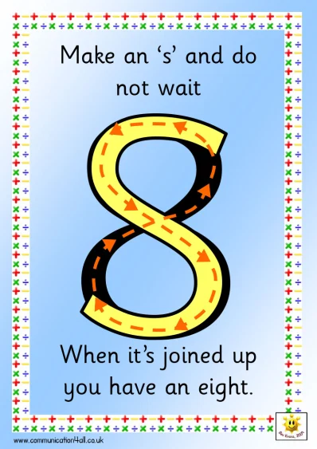
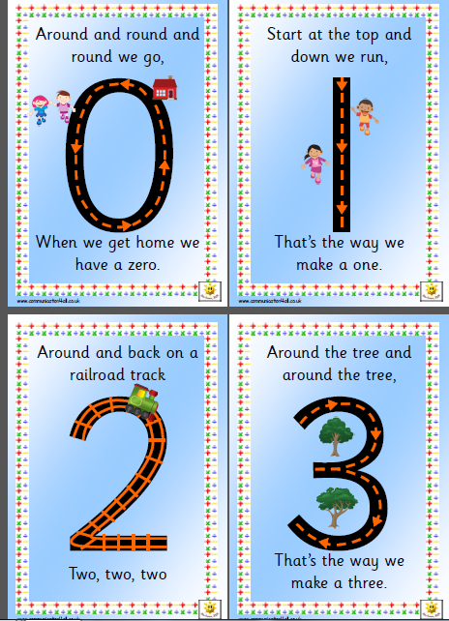
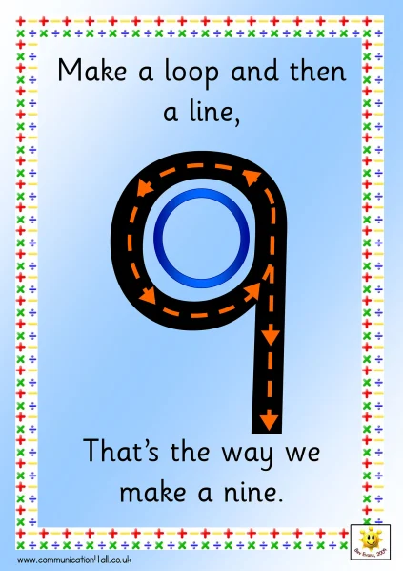
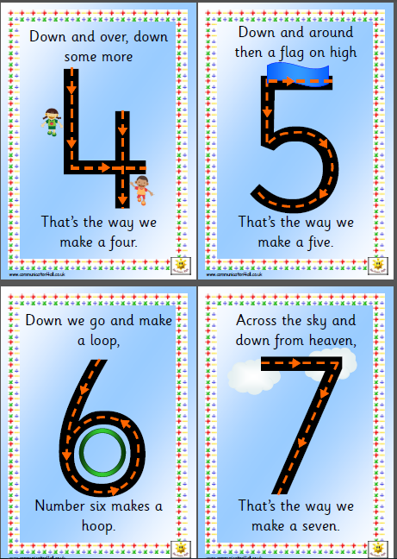
Twinkl
https://www.twinkl.co.uk/search?term=school+closure
Twinkl have made their website free to all users for 1 month meaning you can access any resource completely free of charge. Twinkl covers a very wide range of ages from Early Years up to Key Stage 4 and so there are plenty of resources to choose from.

