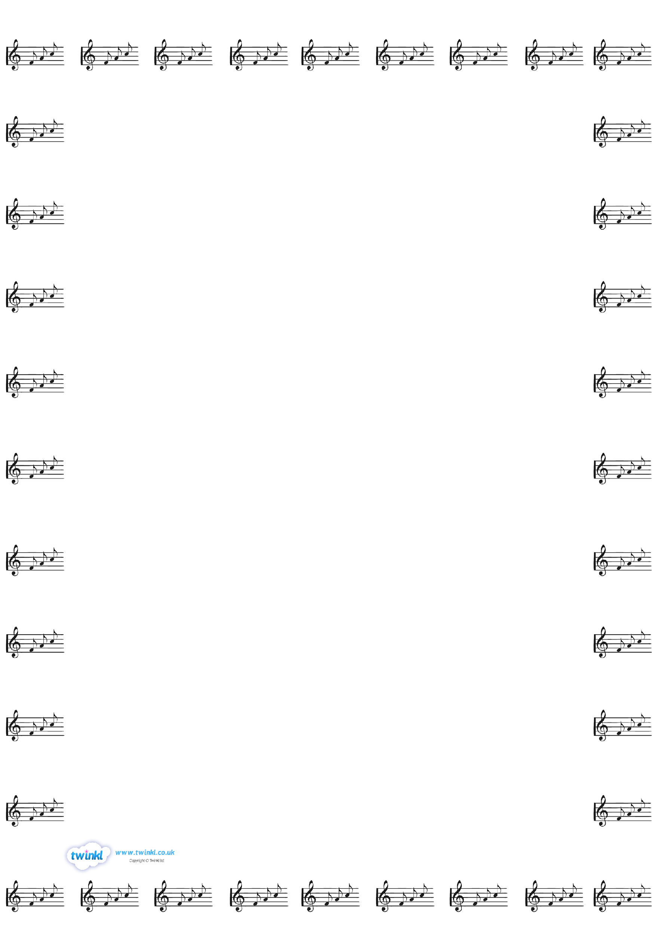

**Cello**

**Monday 8.20 –8.40**

Group A 8.20

Cordelia Seeds 5SB

**Violin**

**Friday 12.20 pm – 1.50pm**

Group E 12.50

Olivia 3HC

Ariana 3AS

Group B 1.10

Olivia 6CW

Zoe 6CW

Group C 1.30

Lily 6CW

Telisha 6MT

Group A 1.50

Asavari 3AS

Isabella 3AS

**Group D 2.10**

Antonio 4LH