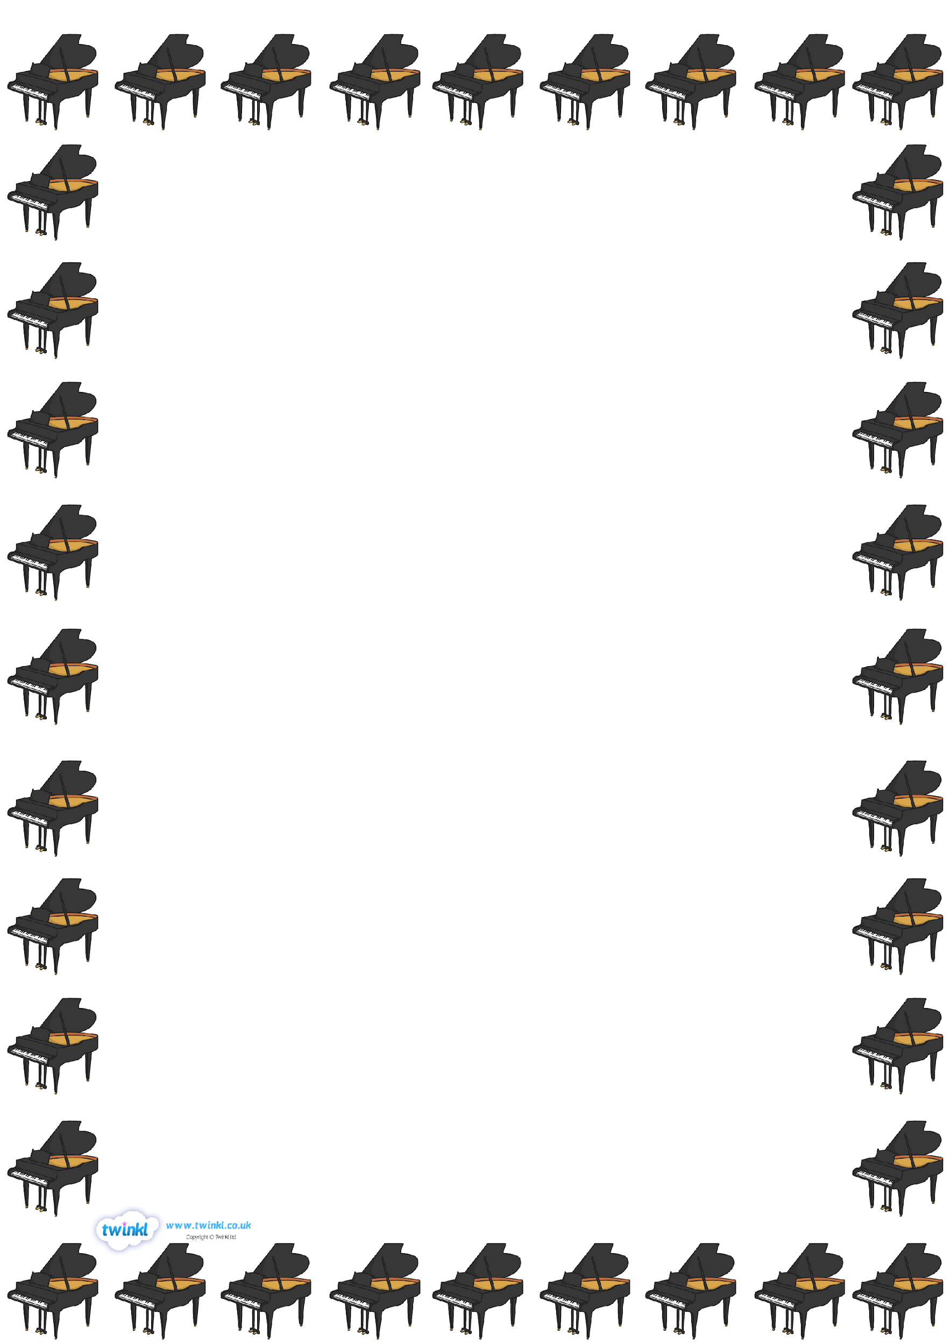

**Piano**

**Monday 8.50 – 11.40**

**Group E 8.50**

Nylah 3AS

Elise 3AS

**Group G 9.10**

Molly F 3HC

Emily 3AS

**Group F 9.30**

Hannah P 4SR

**Group B 9.50**

Albie 4SR

Erin 4SR

**Group A 10.10**

Winifred L 6CW

Scarlett B 6CW

**Group E 10.30**

Izzy 4SR

Darcy 4SR

**Group H 10.50**

Sophie 4SR

Teyha 4SR

**Group I 11.10**

Michael M 6MT 10mins

**Group K 11.20**

Carla B 5SB 10 mins

**Group J 11.30**

Olivia C 5AB 10 mins