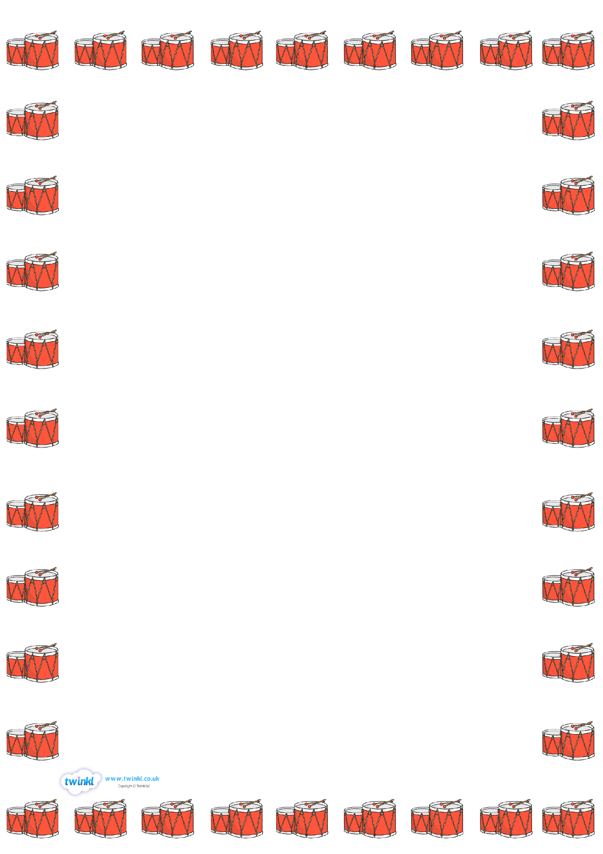

Group C 1.15

Tas 6CW

George 6MT

Group G 1.35

Luca 3HC

Joseph 3HC

Group H 1.50

Joshua D 5AB

Harvey K 3AS

Group E 2.10

Dillon C 5AB

Harrison D 4SR

Group A 2.30

Billy-J

Group F 2.50

Eli T 3HC

Drums

Wednesday 12.55- 3.00

Group D 12.55

Callum B 6MT

Ethan L 5AB

Callum Ballet 5SR

Ethan Lyons 4LH

Group C 9.40 am

James Eccles 4AB

Group B 10.00 am

Tasfaye Powell 5SB

10.20 am

Lewis Watkins 6CW

Anya Inverary 5SB

Group E 9.00 a.m

Dillon Conaty 4LH

Harrison Deegan 3HR

Group D 9.20 am

Callum Ballet 5SR

Ethan Lyons 4LH

Group C 9.40 am

James Eccles 4AB

Group B 10.00 am

Tasfaye Powell 5SB

10.20 am

Lewis Watkins 6CW

Anya Inverary 5SB