Wednesday 17th October, 2018
L.O: To bake
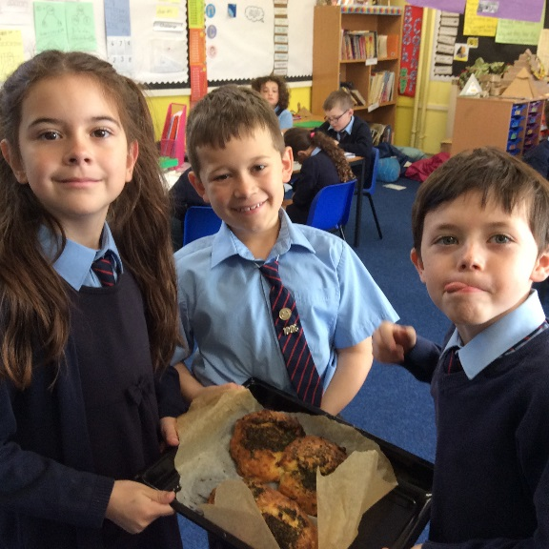
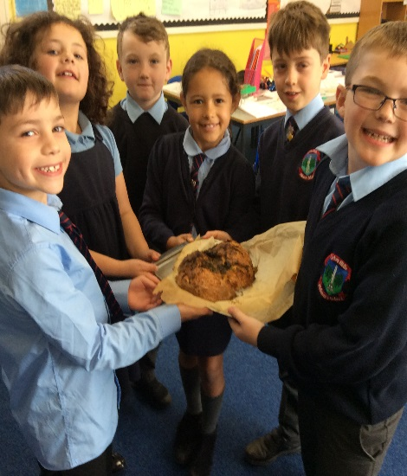
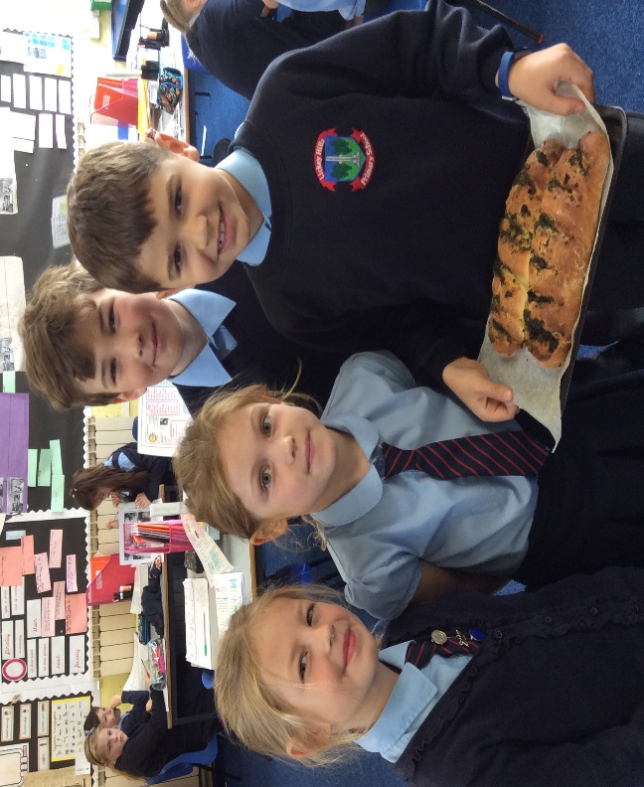
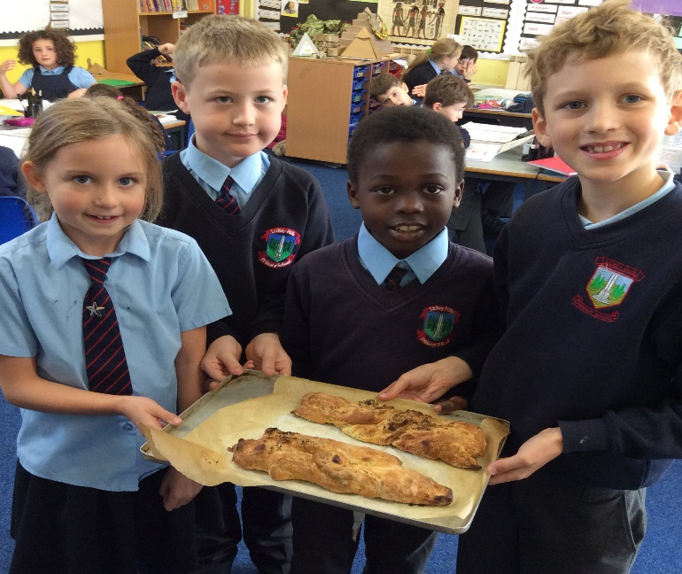
In groups we worked as a team, to follow a recipe to make garlic bread. We made garlic bread because it was a staple food in Ancient Egypt.

